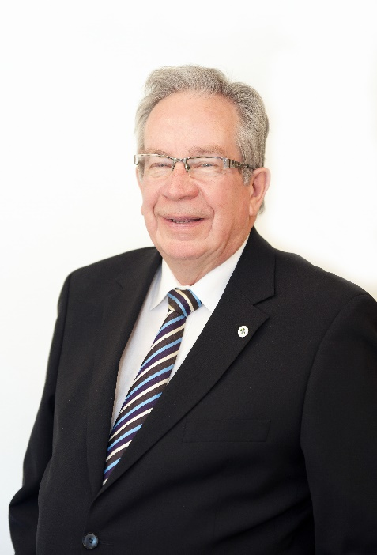

A Message from the Mayor

On behalf of Peterborough City Council, it is my pleasure to extend greetings to all those involved in the 2023 Peterborough Kiwanis Music Festival.

It is wonderful to see the continuation of this Festival after 77 years in existence. This event has always played an important role in celebrating the musical accomplishments of students in our community allowing the participants to showcase their talents and gain confidence in their musical abilities through these performances.

We send our best wishes to all the participants.

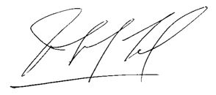

Jeff Leal, Mayor

